**TASK 22 OUTPUT:**

**1.Filling the form , validating it and taking the screenshot of the page:**

**STEPS PERFORMED ARE:**

1. Open the form <https://phptravels.com/demo/>.

2. Form details are filled using locators.

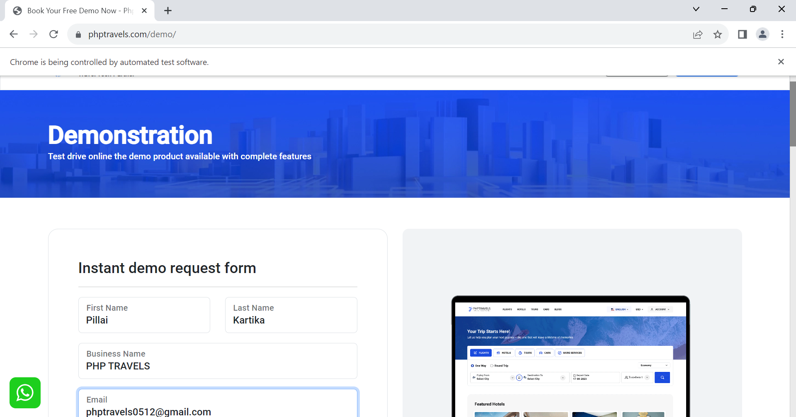

3.Sum operation is done by converting string into integer.

4. Verification for form submit is done.

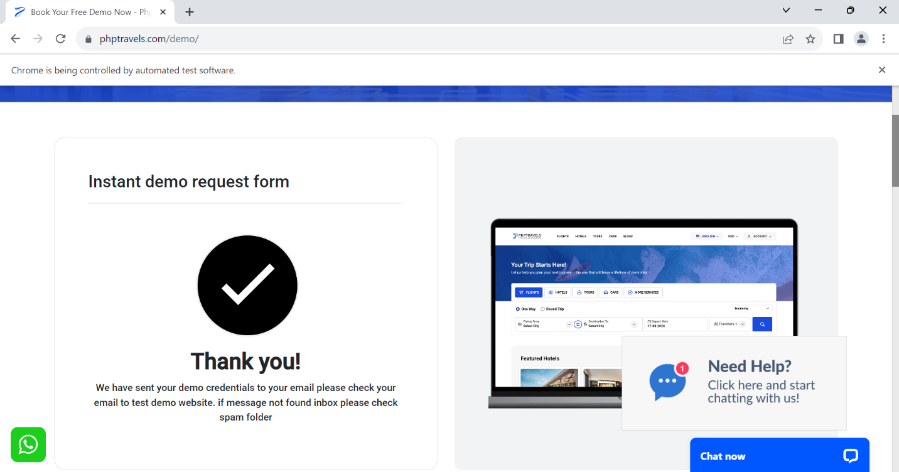

5. Finally screenshot is taken using screenshot.

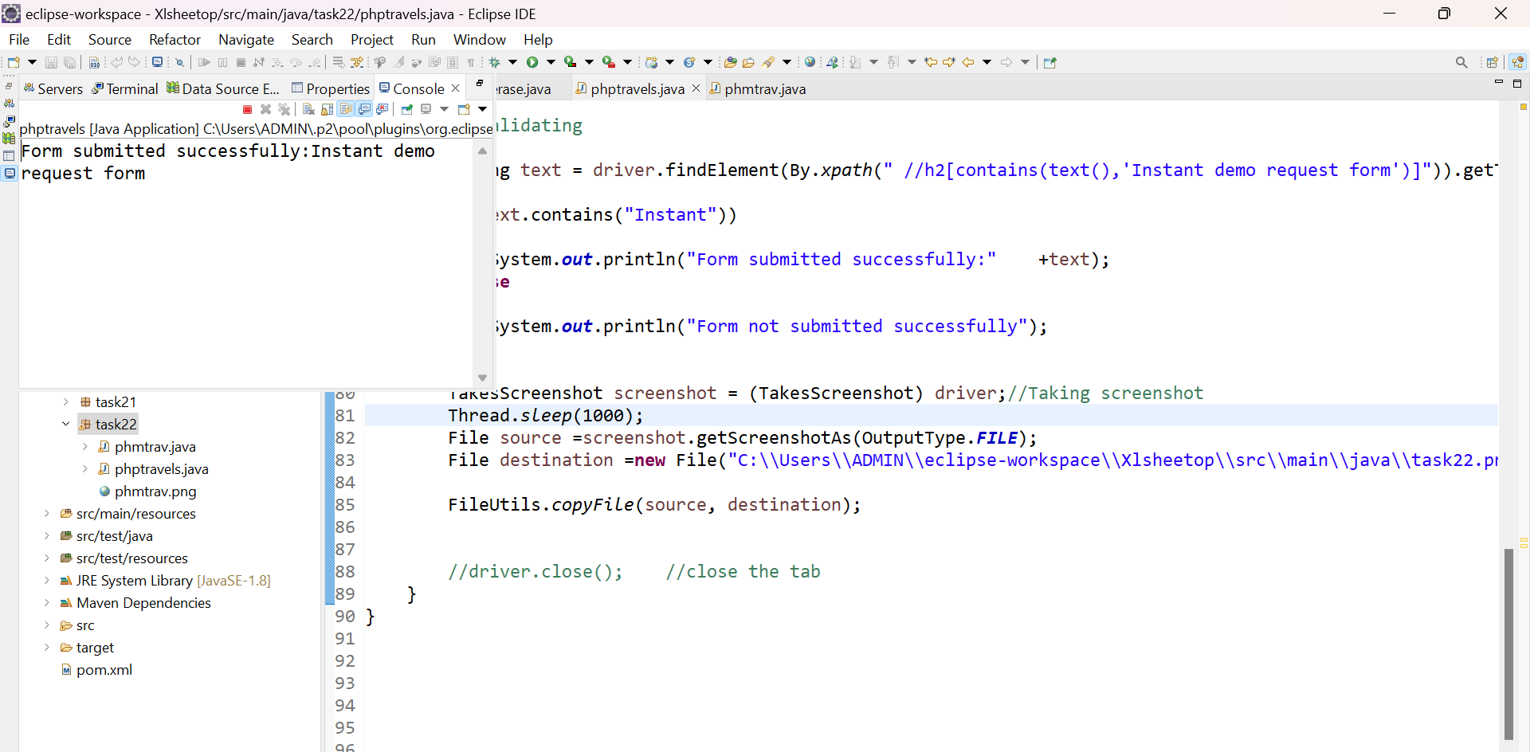

6.Browser is closed.

7.Finally the text is printed on the console.